:Agenda:
- Introduction to Kafka
- Kafka terminology
- Kafka Setup
- Kafka Producers
- Kafka Consumers
- Kafka Internals
- Reliable data delivery
- Stream processing in Kafka
- Appendix: Kafka as Containers (Practical)

Kafka Terminology using Producers and Consumers

Practice 1 - Understanding Partitions
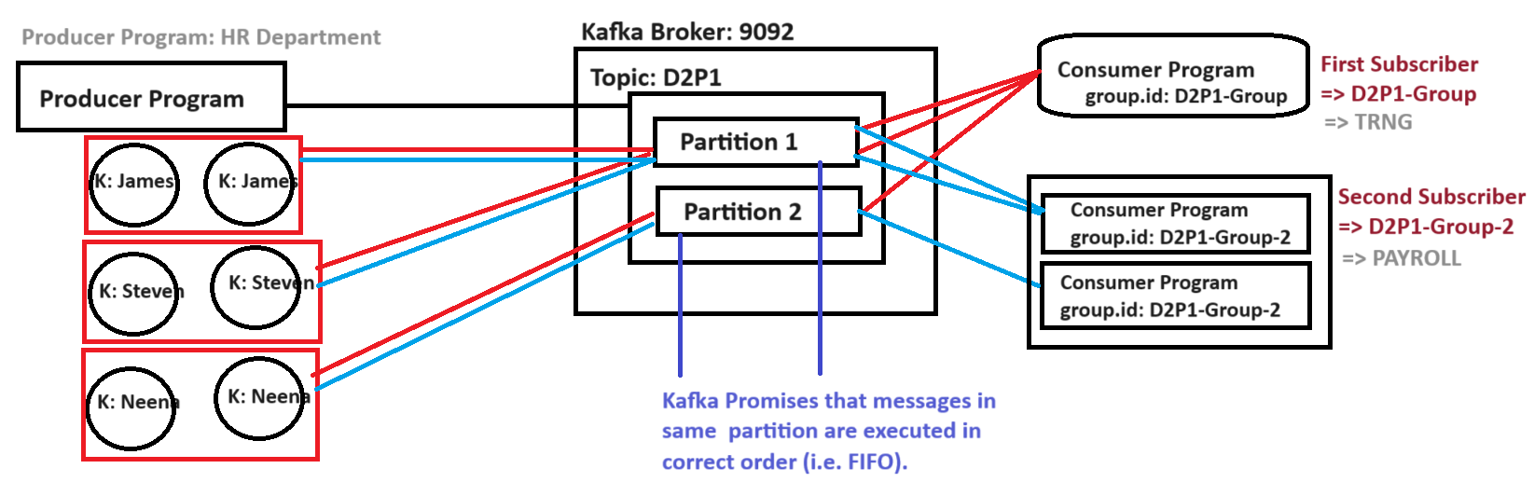
- Create a Topic D2P1 with two partitions
  - Ensure the Zookeeper and Kafka is running
  - Launch a new command prompt and create the Topic D2P1 with 2 Partitions
cd C:\kafka\kafka_2.12-2.5.0
bin\windows\kafka-topics.bat --create --bootstrap-server localhost:9092 --replication-factor 1 --partitions 2 --topic D2P1
- Create D2P1 maven project
    - Click on File → Click New → Click Maven Project
Note: if maven project is not visible, click Other and search for it
    - First Step: Click next
    - Second Step:
      - Search for ‘maven-archetype-quickstart’ using Filter text box
      - Select the ‘maven-archetype-quickstart’ of ‘1.4’ version → Click Next
    - Third Step:
      - Provide the group id as ‘com.example.training’
      - Provide the artifact id as ‘D2P1’
      - Uncheck ‘run archetype generation interactively’
      - Click Finish

  - Update JDK version in pom.xml file
    - Double click on pom.xml file to open it
    - Update pom.xml file to change JDK version from 1.7 to 1.8
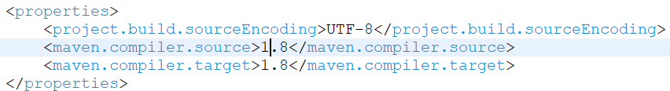
  - Provide the kafka library dependency details
    - Update pom.xml file to add libraries slf4j, kafka-clients
<dependency>
<groupId>org.slf4j</groupId>
<artifactId>slf4j-simple</artifactId>
<version>1.7.32</version>
</dependency>
<dependency>
<groupId>org.slf4j</groupId>
<artifactId>slf4j-api</artifactId>
<version>1.7.32</version>
</dependency>
<dependency>
<groupId>org.apache.kafka</groupId>
<artifactId>kafka-clients</artifactId>
<version>3.0.0</version>
</dependency>
    - The updated file looks as below
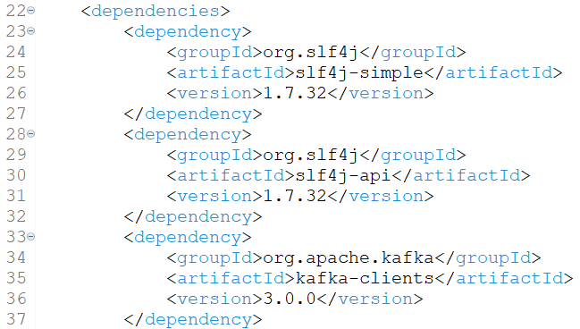
    - Save the changes done to pom.xml file
    - Verify if ‘kafka’ library is visible under ‘Maven Dependencies’
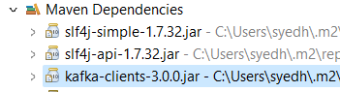
- Create a java class named OneWayProducer.java with below code
package com.example.training.d2p1;

import org.apache.kafka.clients.producer.ProducerRecord;
import org.apache.kafka.clients.producer.KafkaProducer;
import org.apache.kafka.clients.producer.Producer;
import java.util.Properties;

public class OneWayProducer{
public static void main(String args[]){
Properties props = new Properties();
props.put("bootstrap.servers", "localhost:9092");
props.put("key.serializer", "org.apache.kafka.common.serialization.StringSerializer");
props.put("value.serializer", "org.apache.kafka.common.serialization.StringSerializer");

Producer<String, String> producer = new KafkaProducer<>(props);

//James Messages
ProducerRecord james1 = new ProducerRecord<String, String>("D2P1","JCOOPER", "James Customer Update #1");
producer.send(james1);
ProducerRecord steven1 = new ProducerRecord<String, String>("D2P1","SKING", "Steven Customer Update #1");
producer.send(steven1);
ProducerRecord neena1 = new ProducerRecord<String, String>("D2P1","NEENA", "Neena Customer Update Update #1");
producer.send(neena1);
ProducerRecord james2 = new ProducerRecord<String, String>("D2P1","JCOOPER", "James Customer Update #2");
producer.send(james2);
ProducerRecord steven2 = new ProducerRecord<String, String>("D2P1","SKING", "Steven Customer Update #2");
producer.send(steven2);
ProducerRecord neena2 = new ProducerRecord<String, String>("D2P1","NEENA", "Neena Customer Update Update #1");
producer.send(neena2);

System.out.println("6 Messages sent to Kafka topic D2P1");
producer.close();
}
}
- Creating two different subscribers (i.e. different group id)
  - Create OneWayConsumer1.java with below code
package com.example.training.d2p1;

import org.apache.kafka.clients.consumer.KafkaConsumer;
import org.apache.kafka.clients.consumer.ConsumerRecords;
import org.apache.kafka.clients.consumer.ConsumerRecord;
import java.util.Properties;
import java.util.Collections;

public class OneWayConsumer1 {
public static void main(String args[]) {
Properties kafkaProps = new Properties();
kafkaProps.put("bootstrap.servers", "localhost:9092");
kafkaProps.put("group.id","d2p1-group-1");
kafkaProps.put("key.deserializer", "org.apache.kafka.common.serialization.StringDeserializer");
kafkaProps.put("value.deserializer", "org.apache.kafka.common.serialization.StringDeserializer");
KafkaConsumer<String, String> consumer = new KafkaConsumer<String, String>(kafkaProps);
consumer.subscribe(Collections.singletonList("D2P1"));
try {
int i = 0;
System.out.println("----------- Started Polling For Data ----------- ");
while (i < 2000) {
i++;
ConsumerRecords<String, String> records = consumer.poll(100);
for (ConsumerRecord<String, String> record : records) {
System.out.printf("Subscriber 1: Partition = %d, offset = %d, key = %s, value = %s%n", record.partition(),
record.offset(), record.key(), record.value());
}
}
System.out.println("----------- Completed Polling ----------- ");
consumer.close();
} catch (Exception e) {
e.printStackTrace();
}

}
}
  - Create OneWayConsumer2.java with below code
package com.example.training.d2p1;

import org.apache.kafka.clients.consumer.KafkaConsumer;
import org.apache.kafka.clients.consumer.ConsumerRecords;
import org.apache.kafka.clients.consumer.ConsumerRecord;
import java.util.Properties;
import java.util.Collections;

public class OneWayConsumer2 {
public static void main(String args[]) {
Properties kafkaProps = new Properties();
kafkaProps.put("bootstrap.servers", "localhost:9092");
kafkaProps.put("group.id","d2p1-group-2");
kafkaProps.put("key.deserializer", "org.apache.kafka.common.serialization.StringDeserializer");
kafkaProps.put("value.deserializer", "org.apache.kafka.common.serialization.StringDeserializer");
KafkaConsumer<String, String> consumer = new KafkaConsumer<String, String>(kafkaProps);
consumer.subscribe(Collections.singletonList("D2P1"));
try {
int i = 0;
System.out.println("----------- Started Polling For Data ----------- ");
while (i < 2000) {
i++;
ConsumerRecords<String, String> records = consumer.poll(100);
for (ConsumerRecord<String, String> record : records) {
System.out.printf("Subscriber 1: Partition = %d, offset = %d, key = %s, value = %s%n", record.partition(),
record.offset(), record.key(), record.value());
}
}
System.out.println("----------- Completed Polling ----------- ");
consumer.close();
} catch (Exception e) {
e.printStackTrace();
}

}
}

- Executing the program
  - Right click OneWayConsumer1.java → Click on Run As → Click Java Application (Subscriber #1)
  - Right click OneWayConsumer2.java → Click on Run As → Click Java Application (Subscriber #2: First Replica)
  - Right click OneWayConsumer2.java → Click on Run As → Click Java Application (Subscriber #2: Second Replica)
  - Right click on OneWayProducer.java → Click on Run As → Click Java Application
- Observing the execution
  - To view the program instances, click on the drop down arrow over console

  - Consumer1 (i.e. Subscriber 1) output is as below
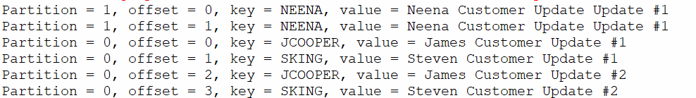
  - Consumer2 Replica 1 (i.e. Replica 1 of Subscriber 2) output is as below
  - Consumer2 Replica2 (i.e. Replica 2 of Subscriber 2) output is as below
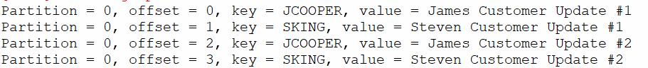
- Notice the offset parameter of Consumer2 Replica1 and Consumer2 Replica2.
For each partition message Kafka uses offset parameter, for tracking the messages consumed.
- DIY: Update the producer to generate two messages with YOUR NAME as key, and find out which consumer replica of Subscriber 2 picks the message

Kafka Cluster
Multiple Kafka Broker instances → Scaling
- Partitioning
- Replication
Scaling: Increasing Capacity
- Increasing the CPU / RAM / Storage → Scale UP
Decreasing the CPU / RAM / Storage → Scale Down
Scale UP + Scale Down → Vertical Scaling
- Increasing capacity by creating another replica → Scale OUT
Decreasing capacity by destroying a replica → Scale IN
Scale OUT + Scale IN → Horizontal Scaling

Example: Consider we have 30 passengers planning to travel from X city to Y city, say the infrastructure is a BUS.
- We have +2 passengers → Customizing Bus to arrange 2 new seats (Vertical Scaling).
- We have +20 passengers → Arranging another Bus (replica – Horizontal Scaling)
In real-time Horizontal Scaling is comparatively cheaper.

Practice 2 - Setup Kafka Cluster
- Stop all the instances of Kafka and Zookeeper.
- Setup the independent Zookeeper using below steps
  - Get the Zookeeper (Zookeeper is used to store the metadata)
- Download Google Drive\Softwares\apache-zookeeper-3.8.1-bin.tar.gz
- Extract the downloaded gz file to get a TAR file in C:\kafka folder, then extract TAR file to get zookeeper folder in C:\kafka(use 7-zip)
  - Get the Kafka & Setup (Store and process the messages) - Already completed
  - Start the Zookeeper process
    - Create a file named ‘zoo.cfg’ within C:\kafka\apache-zookeeper-3.8.1-bin\conf
    - Update zoo.cfg to use below configuration
tickTime=2000
dataDir=C:/kafka/apache-zookeeper-3.8.1-bin/data
clientPort=2181
admin.enableServer=false
    - Start the zookeeper instance using a new command prompt
set JAVA_HOME=c:\Oracle\Softwares\JDK8
cd c:\kafka\apache-zookeeper-3.8.1-bin
bin\zkServer

- Create a copy of server.properties from C:\kafka\kafka_2.12-2.5.0\config by name ‘server1.properties’
- Update server1.properties to use below configuration
broker.id=1
port=9092
log.dirs=C:/kafka/kafka_2.12-2.5.0/logs/server1
zookeeper.connect=localhost:2181
- Update server2.properties to use below configuration
broker.id=2
port=9093
log.dirs=C:/kafka/kafka_2.12-2.5.0/logs/server2
zookeeper.connect=localhost:2181
- Start the first Kafka Broker instance using server1.properties file
cd c:\kafka\kafka_2.12-2.5.0
bin\windows\kafka-server-start.bat config\server1.properties
- Start the second Kafka Server using ‘server2.properties’ using a new command prompt
cd c:\kafka\kafka_2.12-2.5.0
bin\windows\kafka-server-start.bat config\server2.properties
- Verify from Zookeeper using Zookeeper CLI about Kafka Cluster (configuration)
  - Start a new command prompt
  - Execute below commands
set JAVA_HOME=c:\Oracle\Softwares\JDK8
cd c:\kafka\apache-zookeeper-3.8.1-bin
bin\zkCli.cmd -server localhost:2181
  - Execute below command to notice broker ids
ls /brokers/ids
- Do it yourself: Start a third broker of Kafka Server and verify from Zookeeper & Verify in zookeeper if three broker/ids are created.

Practice 2.2 - Using the Kafka Cluster
- Create the topic D2P2 as below
cd C:\kafka\kafka_2.12-2.5.0
bin\windows\kafka-topics.bat --create --bootstrap-server localhost:9092 --replication-factor 2 --partitions 2 --topic D2P2
- Update the OneWayProducer.java as below
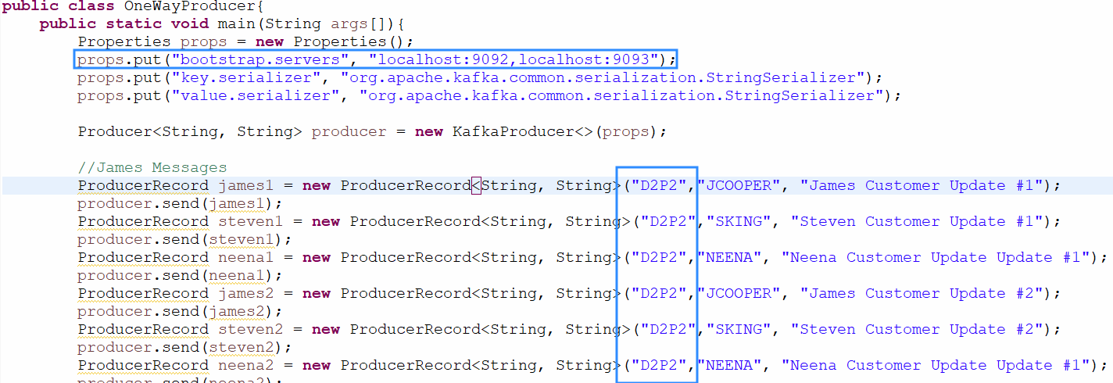
Note: Producer connects to 9092 first, and if 9092 is not accessible 9093 is reached (this is called client side load balancing)
- Update the OneWayConsumer.java as below
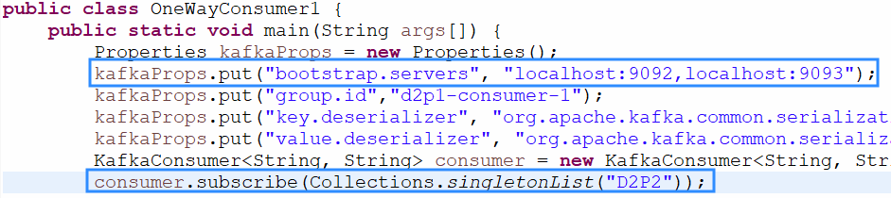
Note: Consumer connects to 9092 first, and if 9092 is not accessible 9093 is reached (this is called client side load balancing)
- Execute Consumer and Producer programs, to ensure Kafka Cluster is accessible

Replication

Practice 2.3 - Understanding Replication
- Execute the following command to create a topic 'learnReplicas' (5 Partitions with 1 Leader and 2 Replicas)
bin\windows\kafka-topics.bat --create --zookeeper localhost:2181 --replication-factor 2 --partitions 5 --topic learnReplicas
- Execute the following command to describe the topic
bin\windows\kafka-topics.bat --describe --topic learnReplicas --zookeeper localhost:2181
- Output would be as below
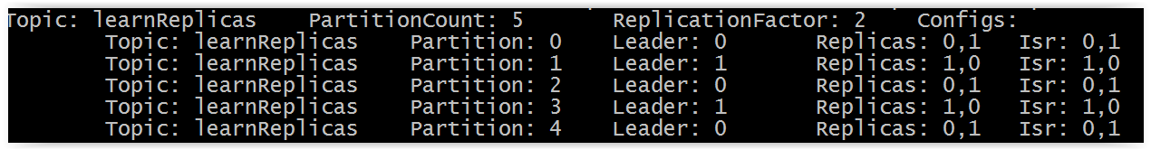
From above output 'Partition:0' has its leader on Broker 0, and Replicas on Broker 1
- Delete the learnReplicas topic
bin\windows\kafka-topics.bat --delete --zookeeper localhost:2181 --topic learnReplicas

Summary:
- Aim is to address Failover requirements at Partition level
- Concept of Replication is “a Partition belonging to Broker 1 is replicated to Broker 2”
- The Replication factor count must match with the number of Brokers available.
- The Partition count need not match with the Brokers available.
- ISR: In Sync Replica
  - The ISR is simply all the replicas of a partition that are "in-sync" with the leader.
  - If a follower fails, then it will cease sending fetch requests and after the default, 10 seconds will be removed from the ISR. Likewise, if a follower slows down, perhaps a network related issue or constrained server resources, then as soon as it has been lagging behind the leader for more than 10 seconds it is removed from the ISR.
  - The ISR acts as a tradeoff between safety and latency.

Reliability
- Message delivery being reliable from kafka’s point of view.
- When can Kafka say “I acknowledge that your message is received by me”
- https://kafka.apache.org/081/documentation.html ⇒ Search for ‘Producer Configs’
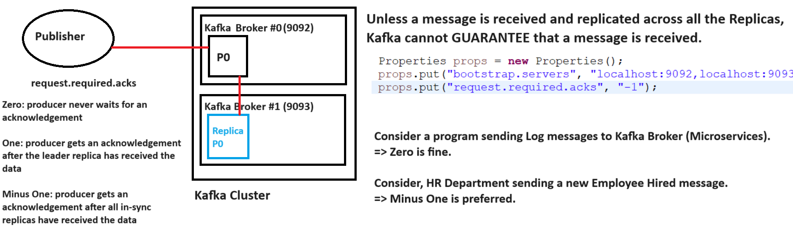

Practice 3 - Implementing Ack within Producer
- Step 1: Create a java class by implementing Callback interface
public class CallbackClass implements Callback{
public void onCompletion(RecordMetadata metadata, Exception e){
if(e!=null) ⇒ Means exception encountered while accept message in Kafka
if(e==null) ⇒ Means record is accepted by Kafka, and metadata has the offset information
}
}
- Step 2: Use the instance of the callback interface while sending the message.
producer.send(record, new CallbackClass());
- Step 3: Update Properties instance to use request.required.acks
DIY:
- Create DelayedResponseProducer.java file using OneWayProducer.java code
- Implementing above steps in DelayedResponseProducer.java code
- Execute Producer code and Consumer code.

Solution for DIY:
package com.example.training.d1p51;  import org.apache.kafka.clients.producer.Callback;  import org.apache.kafka.clients.producer.RecordMetadata;  public class CallbackClass implements Callback {  String message;  public CallbackClass(String msg) {  this.message = msg;  }  @Override  public void onCompletion(RecordMetadata metadata, Exception exception) {  if(exception == null) {  System.out.println("Kafka has received our message : "+ this.message + " into partition: " + metadata.partition());  }else {  System.out.println("Kafka failed to receive our message: " + exception.getMessage());  System.out.println("Please submit the message again.");  }  }  } | public static void main(String args[]){  Properties props = new Properties();  props.put("bootstrap.servers", "localhost:9092");  props.put("request.required.acks", "-1");  props.put("key.serializer", "org.apache.kafka.common.serialization.StringSerializer");  props.put("value.serializer", "org.apache.kafka.common.serialization.StringSerializer");  Producer<String, String> producer = new KafkaProducer<>(props);  //James Messages  ProducerRecord james1 = new ProducerRecord<String, String>("test","JCOOPER", "James Customer Update #1");  producer.send(james1, new CallbackClass("James Update #1"));  ProducerRecord steven1 = new ProducerRecord<String, String>("test","SKING", "Steven Customer Update #1");  producer.send(steven1, new CallbackClass("Steve Update #1"));  }

Kafka as Containers
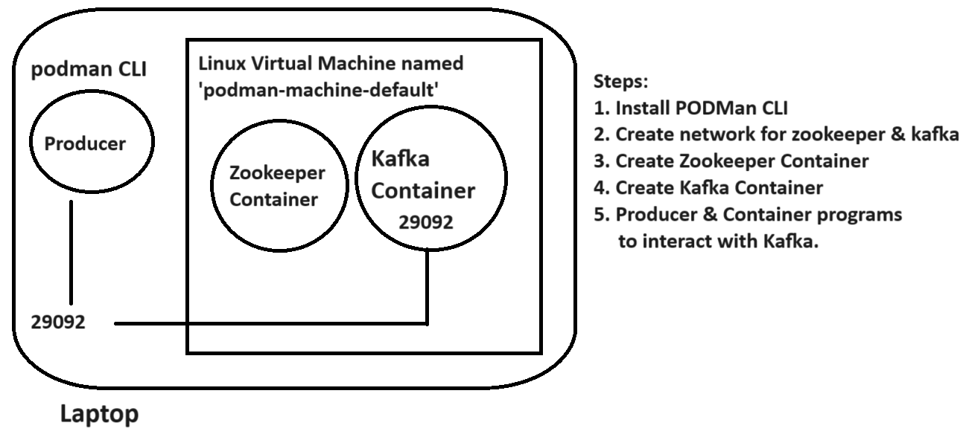

Step1: Installing PODMan CLI
- Download the PODman software
https://github.com/containers/podman/releases/tag/v4.7.0
- Scroll download to locate the installer → Download the installer → Install the PODMan software for your laptop (For MAC machines instructions please browse the link https://podman.io/docs/installation )
- Launch a terminal / command prompt
- Change your working directory to HOME directory
cd $HOME
- Initialize a VM for PODman using below command
podman machine init
- Start the virtual machine using below command
podman machine start
- Verify if the setup is successful using below command
podman version
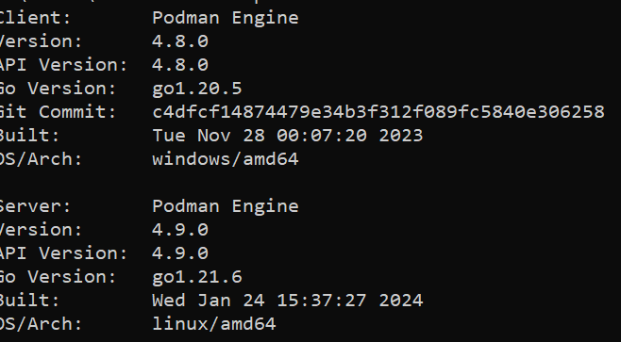
Note: Client is windows and the Server is Linux

Step 2, 3, 4: Creating Network, Zookeeper and Kafka Broker containers
- Launch a new command prompt
- Execute below command to create Network
⇒ podman network create kafka
- Execute below command to create Zookeeper container
⇒ podman run -d --name zookeeper --net kafka -e ZOOKEEPER_CLIENT_PORT=2181 -e ZOOKEEPER_TICK_TIME=2000 -p 22181:2181 confluentinc/cp-zookeeper:latest
Note: source of zookeeper is zookeeper image → confluentinc/cp-zookeeper:latest (which gets downloaded from http://hub.docker.com)
- Execute below command to create Kafka Broker container
⇒ podman run -d --name kafka --net kafka -e KAFKA_BROKER_ID=1 -e KAFKA_ZOOKEEPER_CONNECT=zookeeper:2181 -e KAFKA_ADVERTISED_LISTENERS=PLAINTEXT://kafka:9092,PLAINTEXT_HOST://localhost:29092 -e KAFKA_LISTENER_SECURITY_PROTOCOL_MAP=PLAINTEXT:PLAINTEXT,PLAINTEXT_HOST:PLAINTEXT -e KAFKA_INTER_BROKER_LISTENER_NAME=PLAINTEXT -e KAFKA_OFFSETS_TOPIC_REPLICATION_FACTOR=1 -p 29092:29092 confluentinc/cp-kafka:latest
Note: source of Kafka is Kafka image → confluentinc/cp-kafka:latest (which gets downloaded from http://hub.docker.com)
- Check if the containers are running
⇒ podman container ls
- Connect into Kafka Container
⇒ podman exec -it kafka bash
- Execute commands on Kafka Container $ Prompt
$ kafka-topics --create --topic test --replication-factor 1 --partitions 1 -bootstrap-server kafka:9092
$ kafka-topics --describe --topic test -bootstrap-server kafka:9092
$ exit
- Modify the OneWayProducer.java and OneWayConsumer.java to use ‘localhost:29092’ as the kafka brokers
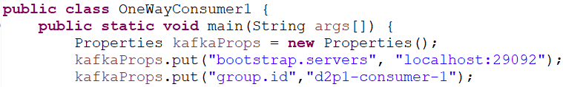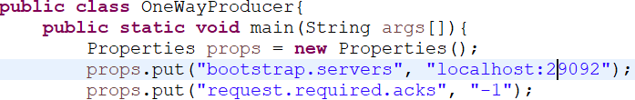
- To stop the containers use below commands
⇒ podman container stop kafka
⇒ podman container stop zookeeper

Let us conclude our discussion for this course
Email: syed.hussaini@live.com

